NHS Humber Health Partnership

Epilepsy
New Patient Information Folder
- Family Services Care Group
- Paediatric Department
- February 2026

Content

Section Page
NHS Humber Health Partnership 1
Epilepsy 1
Content 1
1. Meet the team 2
2. What is epilepsy? 2
3. Causes of epilepsy & living with epilepsy 3
4. What to do when someone has a seizure 4
5. Treatments for epilepsy 8
6. Videos 8
7. Triggers 9
8. Safety 10
9. Keeping a seizure diary 12
10. SUDEP 13
11. School and nursery 13
12. Seizure monitors 13
13. Mental health 14
14. Physical activity 14
15. Sleep 18
16. Useful websites 18

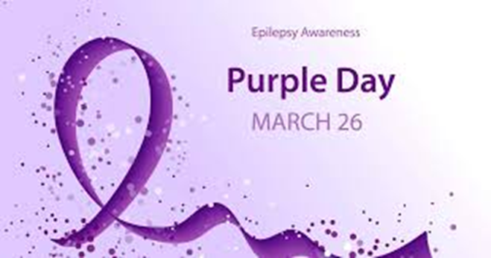

1. Meet the team

The epilepsy team in Hull has 4 nurses and 4 consultants
If you want any help or advice, please contact your epilepsy nurse first. They work office hours Monday- Friday.
01482 674151 – Please note this is not an emergency number. Messages will be checked by the end of the day. Secretaries can also be contacted.

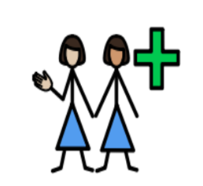
- Christine Bennett
christine.bennett17@nhs.net
- Nicola Heenan
nicola.heenan@nhs.net
- Fiona Lead
fiona.lead1@nhs.net
- Carys Amies
c.amies@nhs.net

- Veronica – Secretary - 01482 674506
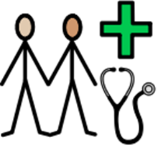
- Dr Jose – Consultant Paediatrician with special interest in Epilepsy
- Dr Mehta – Consultant Paediatrician with special interest in neurodisability
- Dr Rizwan - Consultant Paediatrician with special interest in epilepsy and neurodevelopment
- Dr Omer- Consultant Paediatrician with special interest in epilepsy and neurodevelopment
- Ellie – Secretary – 01482 382673

2. What is epilepsy?
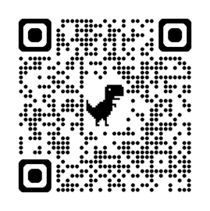

Epilepsy is a common condition that affects the brain and causes frequent seizures.
https://www.epilepsy.org.uk/info/what-is-epilepsy

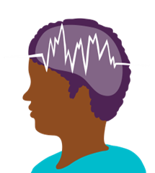
Seizures (also called a fit) are bursts of electrical activity in the brain that temporarily affect how it works. They can cause a wide range of symptoms. If the bursts are happening in the whole of the brain at the same time, the overall seizure type is called ‘General’. If the electrical bursts are in just part of the brain, the overall seizure type is called ‘Focal’. Seizure types in these two groups are then split up further to describe what the specific seizure looks like.

Epilepsy can start at any age but usually starts either in childhood or in people over 60. It's often lifelong, but some children will grow out of it.

Seizures can affect people in different ways, depending on which part of the brain is involved.

Possible symptoms include:
- uncontrollable jerking and shaking
- losing awareness and staring blankly into space
- becoming stiff
- strange sensations, such as a "rising" feeling in the tummy, unusual smells or tastes, and a tingling feeling in your arms or legs
- collapsing

3. Causes of epilepsy & living with epilepsy

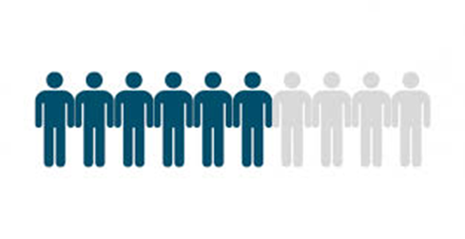
In over half of cases, it's not clear why people have Epilepsy. It's possible it could be partly caused by genes affecting how the brain works, this can be linked to family but not always. The consultants might choose to perform genetic testing but will talk with you about this.
Occasionally, epilepsy can be caused by damage to the brain, such as from a lack of oxygen during birth, a severe head injury or a brain infection.
Epilepsy is often a lifelong condition, but most children and young people with it can have normal lives if their seizures are well controlled. They may have to think about their epilepsy and ask advice before they do things such as swimming, driving, certain courses/jobs, using contraception and planning a pregnancy.
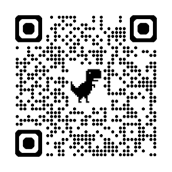
Advice is available from your epilepsy nurse or online support groups to help you adjust to life with epilepsy.
This is a link and QR code for and online course you may want to do
https://learn.epilepsy.org.uk/courses/your-child-and-epilepsy/

4. What to do when someone has a seizure
Generalised tonic-clonic (convulsive) seizures
Tonic-clonic seizures are the type of seizure most people recognise. Someone having a tonic-clonic seizure goes stiff, loses consciousness, falls to the floor and begins to jerk or convulse. They may go blue around the mouth due to irregular breathing. Sometimes they may lose control of their bladder or bowels and bite their tongue or the inside of their mouth.
Here’s how to help if you see someone having a tonic-clonic seizure.
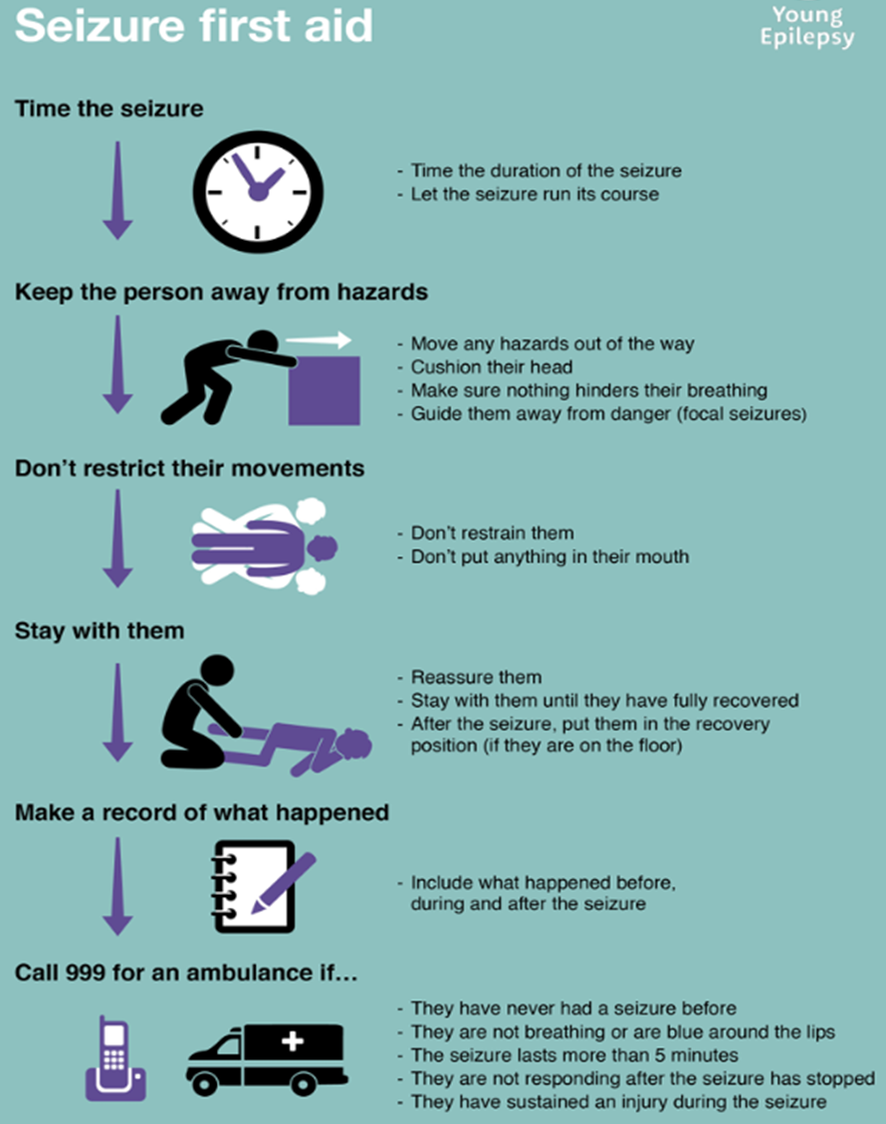

Focal seizures
Someone having a focal seizure may or may not be aware of their surroundings.
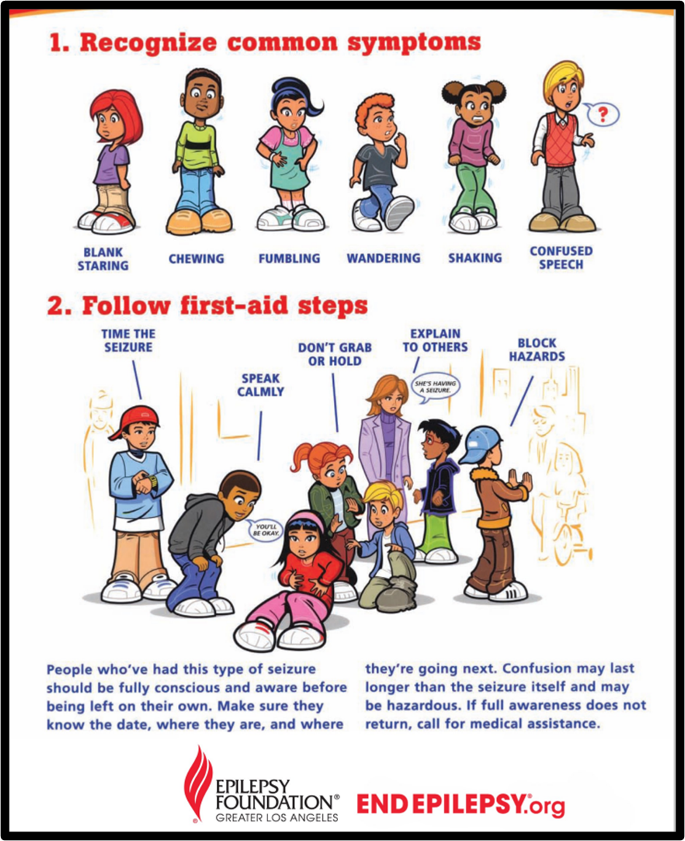

Focal seizures continued…

Call for an ambulance if:
- You know it is their first seizure or
- The seizure continues for more than 10 minutes or as per care plan
- They are injured during the seizure or
- You believe they need urgent medical attention
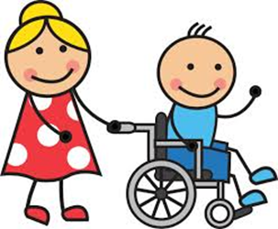
Seizures in a wheelchair
Here is some general advice about how to help someone who is having a seizure in a wheelchair.
- Put the brakes on, to stop the chair from moving. It can help to tilt the chair back.
- Let them remain seated in the chair during the seizure (unless they have a care plan which says to move them). Moving them could possibly lead to injuries for both you and them
- If they have a seatbelt or harness on, leave it fastened - you may need to loosen the straps to allow for movement.
- If they have foot straps you may need to undo these.
- If they don’t have a seatbelt or harness, support them gently, so they don’t fall out of the chair
- Cushion their head and support it gently. A head rest, cushion or rolled up coat can be helpful.
The person’s care plan should give advice on what to do after the seizure has finished. For example, it should say if it is safe to move them from the wheelchair to put them in the recovery position.

5. Treatments for epilepsy

Treatment can help most people with epilepsy have fewer seizures or stop having seizures completely.
Treatments include:
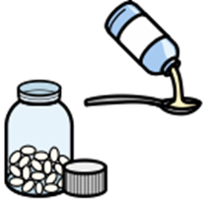
- Medicines called anti-epileptic drugs – these are the main treatment.
- A special diet (ketogenic diet) that can help control seizures – sometimes considered if your child is not responsive to medications. Specialist dieticians in LGI (Leeds General Infirmary) supervise this diet.
- A procedure to put a small electrical device inside the body that can help control seizures (VNS) if medication doesn’t work very well.
- Surgery e.g. to remove a small part of the brain that’s causing the seizures

Some children and young people need treatment for life. It might be possible to stop treatment slowly if seizures disappear over time. If your child is seizure free for 2 years, the consultants will often discuss with you about slowly weaning off medication.

In some children, their epilepsy can be very difficult to manage, and they continue to have a lot of seizures. If this happens, we link with the Tertiary service in Leeds for advice and support.

If your child still has epilepsy at 16, we will transfer their care to the adult epilepsy team. If your child is at a special school, this will usually happen closer to 18. Preparation for this move is called transition.

6. Videos

Seizures can look very different, so we rely heavily on videos of seizures to help us diagnose epilepsy and the type of seizure. It can be very stressful for you to get a video, but this is one of our main ways of diagnosing. This will affect how we choose the best treatment for your child.
Filming a seizure:
- If your child needs first aid or help, then always do this first.
- It is useful to be able to see the whole child. Filming their face is important but we need to see the whole body so you may have to pull back the duvet etc.

- Make sure there is plenty of light. If it’s a night you will have to turn the light on. Turning a light on will not make any difference to the seizure
- Ideally, we would like the whole episode, from ‘before the start’ to ‘after the finish’. Often this is not possible, so any part is useful.
- For some types of episodes, for example if your child is not responding, try to talk to them or touch their face to see if they will respond to you.
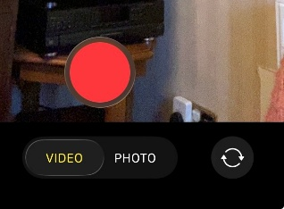
- You can turn the video camera to face you so it’s easier to video while caring for your child.

We have a secure video link called VCreate that we set up with you if you have a video on your phone.

7. Triggers

Most seizures happen without warning so safety can be an issue in things like baths, climbing/heights and around hot objects like fires and cookers. Certain things can make a seizure more likely to happen and can trigger a seizure.
The most common triggers are illness, lack of sleep and missing a dose of anti-seizure medication. Flashing lights triggering seizures (photosensitivity) only happens in about 3% of people with epilepsy. This is often tested for in an EEG.

8. Safety

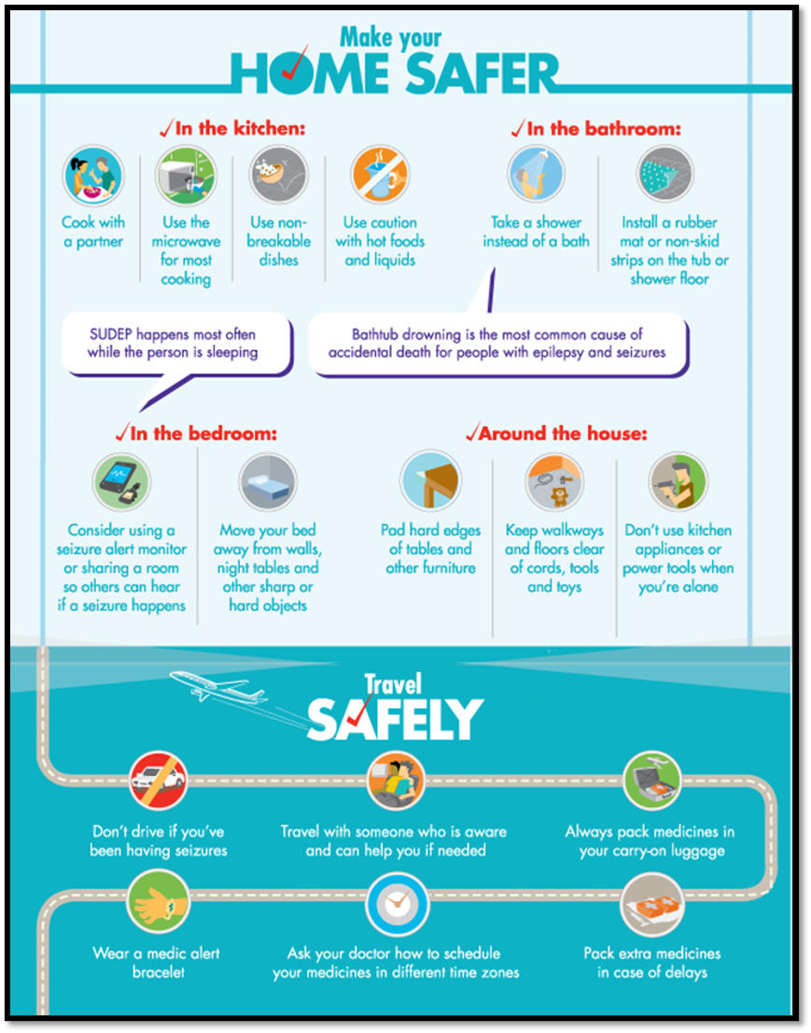


See our short safety video available on YouTube- search for “unseen buddies’ safety” or access via the QR code:

9. Keeping a seizure diary

Even if your child is on medication, taking it at the correct times and is well, there can be times when seizures increase.
By keeping a diary of seizures, you can make us aware when this is happening, and we can look into the reasons why. There are several apps can download to help keep track or you can make a note on a paper calendar. Epilepsy Action have a free paper seizure diary you can order. www.epilepsy.org.uk/info/diagnosis/seizure-diary
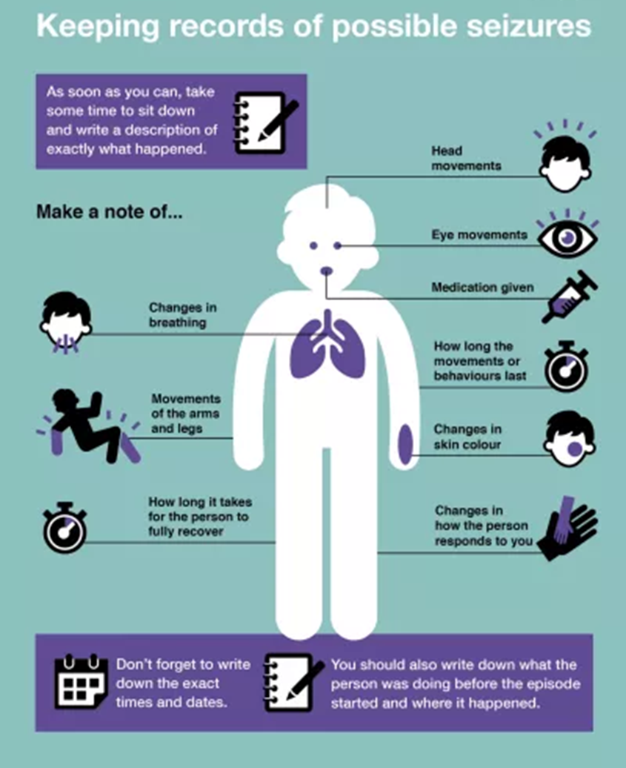

10. SUDEP


SUDEP stands for Sudden Unexpected Death in Epilepsy. It is extremely rare but every year, approximately 1 in 4,500 children with epilepsy die each year with no obvious cause found. This risk increases if you have a more complex, rare form of epilepsy for example, Dravet Syndrome, and also if your child’s seizures aren’t well controlled and they have seizures in sleep.
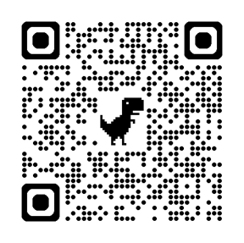
Have a look on SUDEP action on the best ways to reduce risk such as taking medications regularly, informing health professionals of seizures, encourage good sleep patterns.
www.sudep.org/epilepsy-and-risk

11. School and nursery


Most children with epilepsy are able to go to a school, take part in most activities and sports, and get a job when they're older. Epilepsy is more common if children have a learning disability, autism or ADHD so we often advise schools to keep a closer eye on your child and give additional support if needed.
If your child is at school/nursery or has carers, we will write a seizure management plan to let carers know what your child’s seizures look like and what to do if they have one. We can also arrange epilepsy training and support with education.
Taking medication for seizure can have make your child’s thinking a little slower than normal but doesn’t affect their intelligence. If your child is taking medication for seizures the SENCO at the school can ask for 25% extra exam time.

12. Seizure monitors

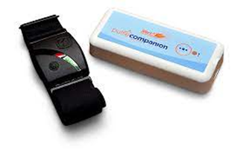
Some children have seizures that are more likely to happen in sleep. Having a nighttime seizure monitor can help you treat seizures that you might not be aware of.
You will need to choose the right sort of monitor carefully to pick up the type of seizures your child has. You may need to speak to a member of the sales team to make sure you get the right monitor.
The NHS do not provide monitors, and they can be expensive. There are a few charities that might be able to help fund the cost of a monitor. They would always be grateful for donations to go towards buying monitors for families unable to buy their own. A list of charity funding is at the end of this booklet.

13. Mental health

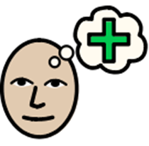
Mental health problems are more common in children and young people with long term conditions like Epilepsy. Both epilepsy and epilepsy medications can affect mental health.
We will ask about emotional or behavioural problems in our clinics.

If you are concerned about your child’s mental health, please discuss with your specialist nurse and consultant. Schools may also be able to support. Apps like Headspace and Calm have useful information and advice to help.

14. Physical activity

Like most long-term conditions, it can make seizures less likely if your child is fit and health. Some of the seizure medications can also make your child eat more, or be more tired, and exercise will help with this too.
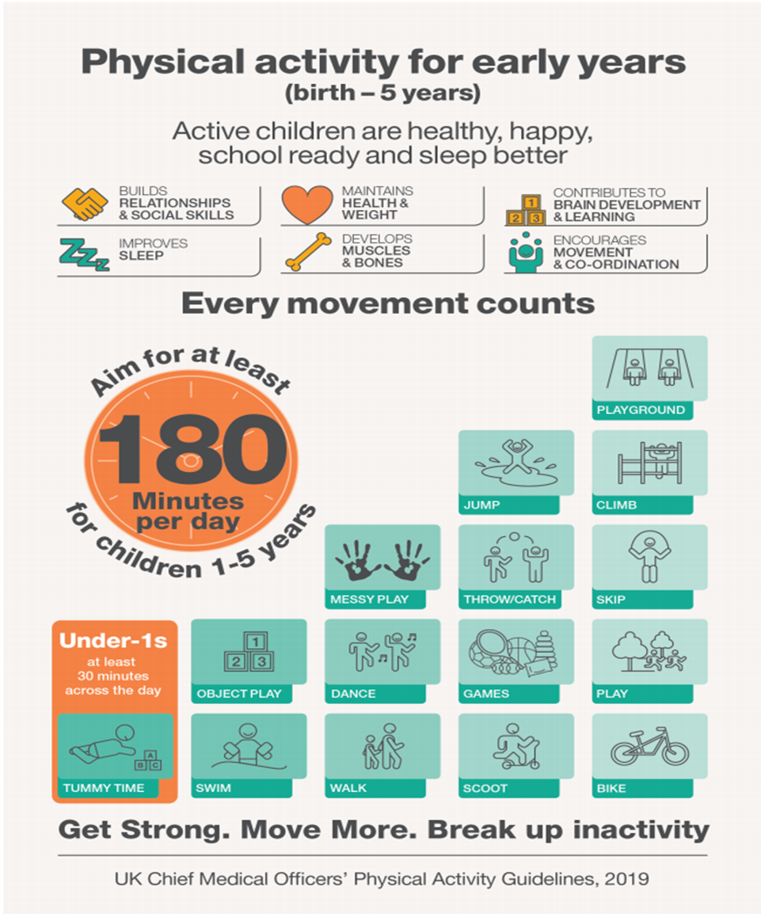
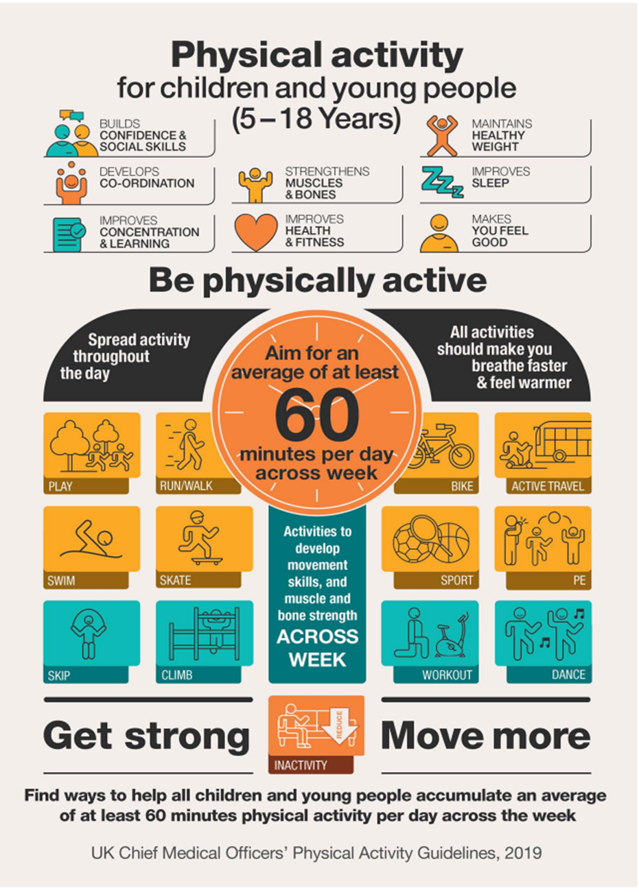

Level of risk of injury or death for young person with epilepsy, or for bystanders, should a seizure occur during an activity (Taken from ILEA guidelines)
Group 1 (no significant additional risk) | Group 2 (moderate risk of injury or death) | Group 3 (high risk of injury or death)
Athletics (expect for sports listed under group 2)  Bowling  Most collective contact sports (judo, wrestling etc)  Collective sports on the ground (basketball, baseball, cricket, football, field hockey, ruby etc)  Dancing  Golf  Racquet sports (tennis, squash, table tennis) | Archery  Athletics (pole vaulting)  Biathlon, triathlon, modern pentathlon  Canoeing  Cycling  Fencing  Gymnastics  Horse riding (eg Olympic equestrian events, dressage, eventing, show jumping)  Skateboarding  Skating  Snowboarding  Swimming  Weightlifting | Being a pilot  Climbing  Diving (platform, springboard)  Horse racing (competitive)  Motor sports  Parachuting (and similar sports)  Scuba diving  Ski jumping  Solitary sailing  Surfing, windsurfing
Be aware if withdrawing from treatment and discuss with your epilepsy team

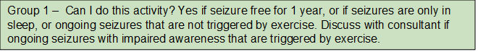
SEIZURE RISK DURING DIFFERENT- TYPES OF EXERCISE

15. Sleep

Lack of sleep is a common trigger for seizures. Below are some tips on how to improve your child’s sleep.
- Keep a regular bedtime for your child and wake your child at a regular hour every morning, so that the body clock is strengthened.
- Do not let your child have prolonged naps in the late afternoon. If your child still needs to sleep, schedule the nap for early afternoon.
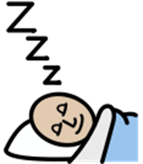
- Avoid stimulating activity in the hour before bedtime, including TV, tablets and gaming.
- Avoid drinks of cola, chocolate, tea and coffee i.e. caffeine and additives before bedtime. Instead, have a warm milk drink or water.
- Make sure that your child does not go to bed hungry but try not give a child over 6 months old feeds/drinks during the night.
- Make sure that your child’s room is quiet and dark.
- Keep room temperature to a comfortable level. High temperatures disturb sleep.
- Keep room clear of distractions and electronic equipment such as TV and game consoles.
- Environmental noise should be kept to a minimum (no loud TV in the house).
- Help your child to learn to fall asleep alone in his/her bed, without your presence

16. Useful websites

Epilepsy
Epilepsy Action – www.epilepsy.org.uk, FB, Twitter, YouTube – ‘What is Epilepsy?’ (Brief video explaining epilepsy)
Young Epilepsy – www.youngepilepsy.org.uk, FB, Twitter, YouTube
SUDEP Action – www.sudep.org, FB, Twitter, YouTube
Mental health support
Young minds - www.youngminds.org.uk, FB, Twitter
Local Hull support - howareyoufeeling.org.uk
Head Space App - www.headspace.com
Calm App - www.calm.com
CHARITY FUNDING
Friends of Freddie
Hull and Humber area only www.freddiesfriends.org
Children Today
Phone: 01244 33 5622
Website: www.childrentoday.org.uk
Nice 2B Nice
Facebook: Nice 2b Nice
Email: nice2bnice72@yahoo.com
Family Fund
Phone: 01904 550 055
Email: Info@familyfund.org.uk
www.familyfund.org.uk
When you wish upon a star foundation
Phone: 01472 827 100
Email: Lincs/yorks@whenyouwish.org.uk
www.whenyouwishuponastar.org.uk/
Disability Grants
www.disability-grants.org
The Daisy Garland
https://www.thedaisygarland.org.uk/
Further information
How to manage seizures - www.epilepsy.org.uk/info/firstaid
Basic epilepsy advice - www.nhs.uk/conditions/epilepsy
Sport and leisure and epilepsy - www.epilepsy.org.uk/info/daily-life/sports-leisure
Sleep advice – www.thesleepcharity.org.uk
General disability advice - Contact a family – www. contact.org.uk
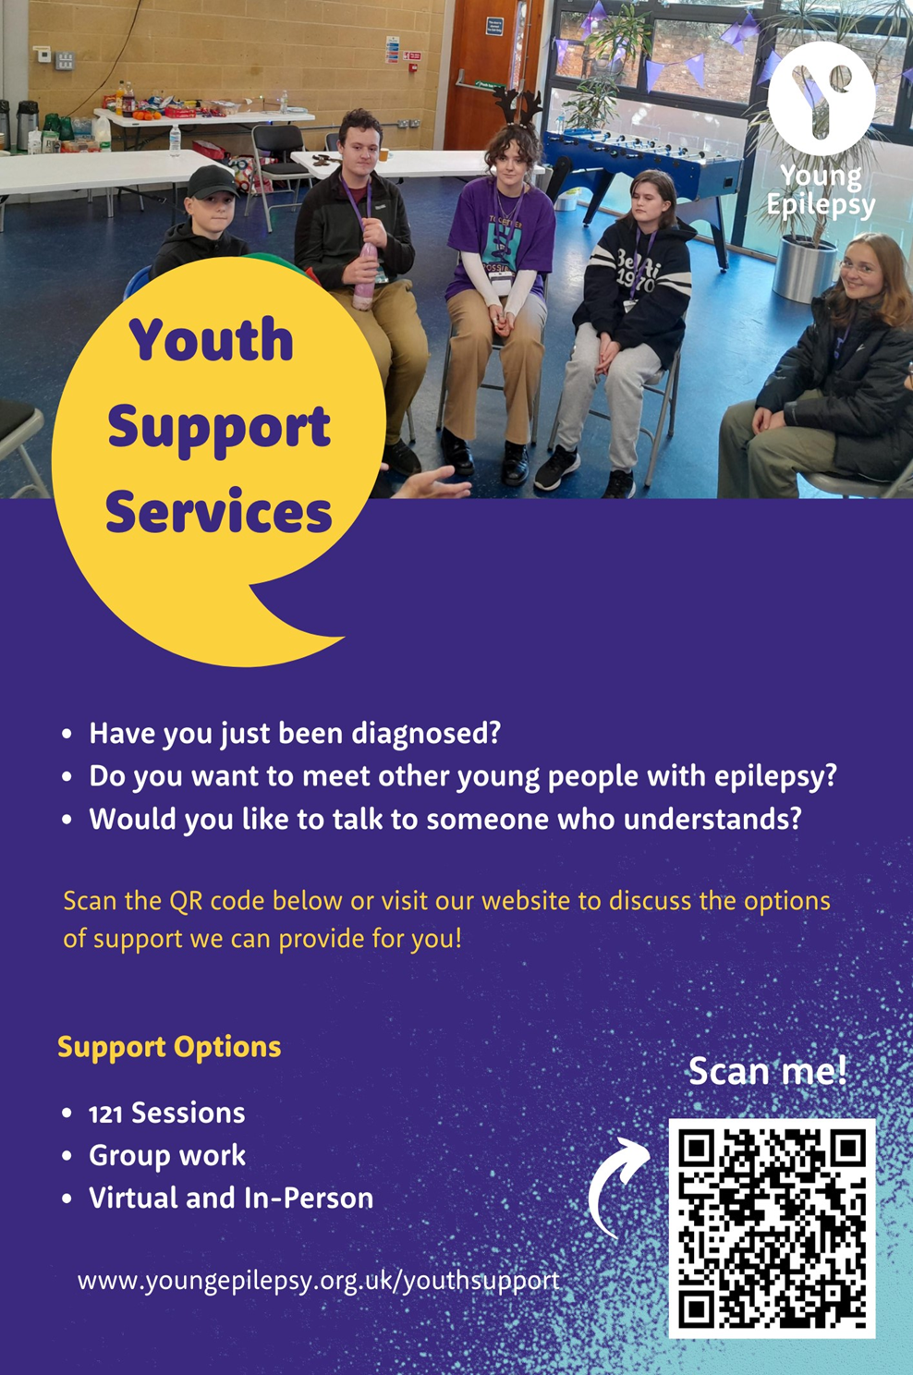
This leaflet was produced by the Children’s Epilepsy Team, Hull University Teaching Hospitals NHS Trust and will be reviewed in February 2029.

Ref: HEY1617/2026
Author: Children’s Epilepsy Team
Review Date: February 2029

