Cerebral Palsy Information Folder
For Children, Young People and their Families

Version | 1.1.1
Date | December 2025
Document Owner | Dr Jose, Hull University Teaching Hospitals Trust

Contents

Contacts 3
Section 1 - What is cerebral palsy? 5
Definition 5
Causes of cerebral palsy 5
Types of cerebral palsy 5
Section 2: Living with Cerebral Palsy 7
What may happen in the future? 7
Who will we see? 10
What advice and support should we expect? 11
Section 3 – How we can help 12
Interventions 12
Local Support 17
Section 4 - Helpful Information 22

Contacts
As a new patient, please find contacts for all members of the Hull University Teaching Hospitals Trust team who can support you:
- Email hyp-tr.huthcerebralpalsy@nhs.net for all non-urgent queries
- Rachael Ellis
Cerebral Palsy Specialist Nurse
07789367855
Rachael.Ellis13@nhs.net
- Jacqueline Best
Complex Care Specialist Nurse
07387 049931
Jacqueline.Best@nhs.net
- Dr Jose, Consultant Paediatrician (Neurodisability and Epilepsy)
Dr Mehta, Consultant Paediatrician (Neurodisability and Epilepsy)
Please contact their secretaries by telephone: 01482 382673

Section 1 - What is cerebral palsy?

Definition
Cerebral palsy mainly affects how the brain controls muscles and movement. Sometimes it can also affect other ways the brain works, such as how we see, hear, communicate, feel, understand and think.
Cerebral palsy is caused when a problem occurs in the development of a baby's brain before, during or soon after they are born. The brain cannot send messages to different parts of the body properly, and this causes problems with things like balance, movement and coordination, talking, chewing and swallowing.
Everyone with cerebral palsy is affected differently – symptoms vary widely, and the effects can range from minor problems to severe disability.
Although there is no cure for cerebral palsy, the problem in the brain that causes it does not get worse over time. However, as a child grows and develops, the effects of cerebral palsy may change over time. Treatment and support can be given to help children and young people cope with their symptoms and become as independent as possible.

Causes of cerebral palsy
Some common causes of cerebral palsy are:
- A problem in the way the brain develops in an unborn baby
- An infection in the baby before or shortly after birth
- A difficult or early (preterm) birth
There is no single cause of cerebral palsy, though prematurity and stroke are two of the biggest causes.
While the cause remains unknown for most cerebral palsy cases, researchers now know that only a tiny percentage of cerebral palsy cases arise from birth-related complications, such as lack of oxygen. It is scientifically accepted that cerebral palsy usually arises from a series of events that combine to cause injury to the developing brain.

Types of cerebral palsy
There are different types of cerebral palsy depending on how movement and muscles are affected. The most common is called spastic cerebral palsy, where the muscles are stiff and movements can seem jerky.
Less common types, such as dyskinetic (dystonic) or ataxic cerebral palsy, lead to problems with the control of movement or balance. Mixed cerebral palsy is a combination of other types.
Your child's doctor should explain more about the type your child has.
Several cerebral palsy classification systems exist today to define the type and form of cerebral palsy an individual has. Knowing the severity, location and type of cerebral palsy your child has will help to coordinate care and treatments.
The infographic in the next page offers a visual summary of the different types and associated impairments.

Section 2: Living with Cerebral Palsy

What may happen in the future?
When families are told that their child has cerebral palsy, they often have lots of questions about what may happen in the future. Your child's outlook (prognosis) depends on how severely their cerebral palsy affects them. For example, some children have more problems than others learning skills like walking and talking. Most people with cerebral palsy have a normal life expectancy, but those with added severe complications have a higher risk of shorter lives. All children are different, and your care team can give you more specific information about the outlook for your child.

Walking
Children who can sit without help by the age of two are likely (but not certain) to be able to walk without help by the time they are six. This may still be possible if they can roll at two, even if they cannot sit. If they cannot sit or roll by this age, they are unlikely to be able to walk without help.

Talking
It is very common for children with CP to have speech difficulties. Some are unable to speak and rely on non-verbal forms of communication.
Cerebral palsy can affect a person’s ability to coordinate the muscles around their mouth and tongue, which are needed for speech. About 1 in 3 children with cerebral palsy have difficulties with speech and language – this is more likely in children with some types of cerebral palsy than others. One in 4 people with cerebral palsy cannot talk. Problems with communicating are more likely if your child also has problems with learning or has epilepsy that is difficult to control.

Pain
Three in 4 children with cerebral palsy experience pain. Pain is often a result of the impairments that are associated with cerebral palsy, such as stiffness, abnormal postures, uncontrolled movements, skin breakdown, hip problems and curvature of the spine.

Eating and drinking issues
Cerebral palsy can affect the muscles that open and close the mouth and move the lips and the tongue. Some people with cerebral palsy may have difficulties in chewing and swallowing – a condition known as dysphagia.
Cerebral palsy often affects fine motor skills, making it trickier to easily use cutlery, hold a cup, or transfer food from a plate to their mouth using their hands.
Others may suffer from gastroesophageal reflux – where acid from the stomach rises into the oesophagus – which makes eating uncomfortable or painful. This can sometimes be controlled by medication.
One in 15 children with cerebral palsy are unable to take food through their mouth and need to be fed through a feeding tube.
Constipation is also much more common in children with Cerebral Palsy

Saliva control
As cerebral palsy can affect the muscles around the mouth, 1 in 5 children with cerebral palsy have saliva control issues that can cause dribbling or drooling. This may be more noticeable when they are concentrating.
Speech therapists may suggest various strategies to help people manage saliva. Your child’s specialist will also be able to assess and advice on medical management options

Intellectual disability
One in 2 people with cerebral palsy have an intellectual disability. One in 5 people have a moderate to severe intellectual disability. Generally, the greater the level of a person’s physical impairment, the more likely it is that they will have an intellectual disability.

Learning difficulties
Children with cerebral palsy may experience specific learning difficulties. These may include a short attention span, organisation and sequencing difficulties and language difficulties. These can affect literacy, numeracy and other skills. Children with cerebral palsy need to put more effort into concentrating on their movements and sequence of actions than others, so they may tire more easily.

Hearing impairment
One in 20 people with cerebral palsy also have some level of hearing impairment. One in 50 children with cerebral palsy are deaf.

Vision impairment
Vision impairment is not uncommon in people with cerebral palsy. Children with the more severe forms of cerebral palsy are more likely than others to experience issues. They may need glasses or have a squint. One in 10 children with cerebral palsy are blind.

Behaviour and emotional wellbeing
Behavioural problems occur in 1 in 4 children with cerebral palsy. At greatest risk are those with an intellectual disability, epilepsy, severe pain or a milder level of physical disability. Problem behaviours include dependency, being headstrong, hyperactive, anxious, or prone to conflict with their peer group. Children with cerebral palsy may also have emotional problems such as difficulties with their peer group and strong emotional responses to new challenges. Teenagers and adults with cerebral palsy may be more prone to depression and anxiety disorders.

Epilepsy
1 in 4 children with cerebral palsy have epilepsy. When children have cerebral palsy and an intellectual disability, the incidence of epilepsy is higher – 48%. Seizures can affect speech, intellectual functioning and physical functioning. Medication is the most effective intervention for epilepsy and your child’s doctor, or specialist nurse may also recommended modifications to the student’s school supports and equipment. Some medications have side effects which cause drowsiness or irritability. Both epilepsy and the related medication can affect a person’s behaviour and attention span.

Respiratory health
Children with cerebral palsy (CP) often face respiratory challenges, and early recognition and management are crucial. The risks are related to severity of cerebral palsy (CP can cause muscle weakness, impacting breathing and the ability to cough effectively, leading to difficulty clearing secretions), problems with swallowing and coordination can increase the risk of aspiration (food or liquids entering the lungs), leading to pneumonia and other infections, ongoing seizures and gastroesophageal reflux symptoms. Children with multiple risk factors are susceptible to recurrent infections, difficulty in breathing especially around mealtimes, coughing problems.

Sleep issues
1 in 5 children with cerebral palsy have a sleep disorder. There are a range of contributing factors, including the muscle spasms associated with cerebral palsy, other forms of musculoskeletal pain, and decreased ability to change body position during the night. Epilepsy is also known to disturb sleep and is likely to predispose to sleep disorders. Blindness or severe visual impairment can affect the timing and maintenance of sleep through their effect on melatonin secretion and the lack of light perception.

Bone health including Spinal and hip abnormalities
There are several skeletal conditions that people with CP are at risk for throughout their lifespan. The risk factors for these conditions will vary by the type of Cerebral palsy
Abnormalities of the spine and hips are associated with cerebral palsy and can make sitting, standing and walking difficult, and cause chronic pain. 1 in 3 children with cerebral palsy have hip displacement. Children and adults who have a severe physical disability or those whose body is affected on both sides are at greater risk of hip problems. This means that people who use wheelchairs most of the time are more at risk of hip problems than those who walk with assistive devices or independently. There is also risk of developing progressive foot and knee deformities

Bladder and bowel control
Continence and constipation are issues for many people with cerebral palsy. 1 in 4 children with cerebral palsy have bladder control problems. Children with intellectual disability and/or a severe form of cerebral palsy are most at risk. Lack of mobility and difficulty eating can predispose people with cerebral palsy to constipation.

Who will we see?
Your child will be cared for and supported by a multidisciplinary team (or MDT for short) of health, education and social care professionals. The team should make sure that you and your child have a central role in making decisions about care and work closely together to support your family and meet your child's needs. They should keep you involved when they contact each other so that you know what is happening and keep your GP up to date about your child's care.
Professionals your child might see:
- A Neurodisability paediatrician (a doctor who works with children)
- Other doctors specialising in different areas your child needs support with (Gastroenterologist, respiratory specialist, Orthopaedics, spinal surgeon, neurosurgeon)
- Nurses (Community Nurse, Specialist nurses)
- A physiotherapist, who helps with movement and positioning
- A dietitian, who helps with nutrition
- A speech and language therapist, who helps with communication and swallowing
- An occupational therapist, who supports people to carry out their everyday activities
- A psychologist, who can help with emotion, behaviour and learning
- A social worker
- We may also arrange to see your child in an MDT clinic with Therapist, Dietician, Respiratory team, specialist nurses based on individual needs
Parents and carers know their child best and can often spot problems earlier than anyone else (including doctors and therapists) – so your care team will always strive to take your views and concerns seriously.

What advice and support should we expect?

Information
When you find out your child has cerebral palsy, you will be told what this means, and what kind of treatment and support they might need. It is important to focus on what your child can do, not on what they cannot. Your child's care team will help them build on their strengths and to become as active and independent as possible.
You and your child will be given information whenever you need it. We have also included contact details for the key team members. If English is not your family's first language, please let us know and an interpreter will be provided if you need one.

What else should we be told about?
- Financial support that you may be entitled to.
- Social support to help ensure that your child is as active and independent as they can be within your family, as well as help with their care.
- How to get equipment for your child, like wheelchairs or walking support, and help with transport.
- How to get regular assessments of your own care and support needs.
- What respite care is available, to help you have a break from your caring responsibilities.
- Local support groups, both for your child and for you and your family, which can provide emotional and other support.
- Voluntary organisations that can also give information and support.
- Other services for children and young people with cerebral palsy, such as sports clubs, social groups and specialist schools.

Sex and sexuality
Older children and young people will be signposted to their own information about sex education and related topics available locally. This will cover things like having periods (for girls), sex, sexuality, contraception and starting a family.

Sharing information
Your care team should work with you and your child to put together information that is unique to your child – a 'personal file'. To facilitate this, we will send a copy of all clinic letters to parents and carers. It can be shared with everyone who supports your family, including friends, family members, health professionals, social workers and teachers. It could include your child's medical history, information about their abilities, conditions, medicines and other treatments, care plans, any special communication needs, equipment needs, and who to contact in an emergency.

Making decisions together
You and your child should be at the centre of all decisions, so that you can agree the care and support that is best for them. Every child and family are different, and the care team will talk to you about their and your needs. They will involve you by:
- checking regularly and talking to you about whether and how your child's care needs are changing as they grow up, and explaining about the options that are available at every stage
- talking to you so that they understand what matters to you – for example, they should respect any social, cultural, spiritual or religious support that is important to your family
- explaining if they think something that is mentioned here won't work for your child and why, and discussing other options you could try instead
- giving you details of someone in the care team that you can contact if you have any questions.
- regular follow up with the multidisciplinary team will be offered to your child to monitor them for any emerging co-occurring issues.

Section 3 – How we can help

Interventions
Do you have a goal that is important to you? A goal that would improve your everyday life or inclusion in activities you want to do with family, friends or peers. This may include activities such as sitting, walking, reaching out for toys or tying shoelaces, kicking a ball, dancing, riding a bike, improve your speech, eat your meals independently, and be comfortable in your chair. Please discuss your goals with your therapy team to work on the movement required to achieve your goal. Regular practice and joint working will allow us to support you in achieving your goals.

Movement issues - Physiotherapy
Physiotherapists and occupational therapists focus on encouraging a person’s day-to-day movement skills such as sitting, walking, playing, dressing and toileting. They will use a range of specialist interventions such as movement training and equipment, e.g. walking frames, wheelchairs, supportive seating, footwear and orthotics.
You may be allocated a physiotherapist either from the community trust or the hospital trust, this usually is age and postcode dependent.

What do physiotherapists do?
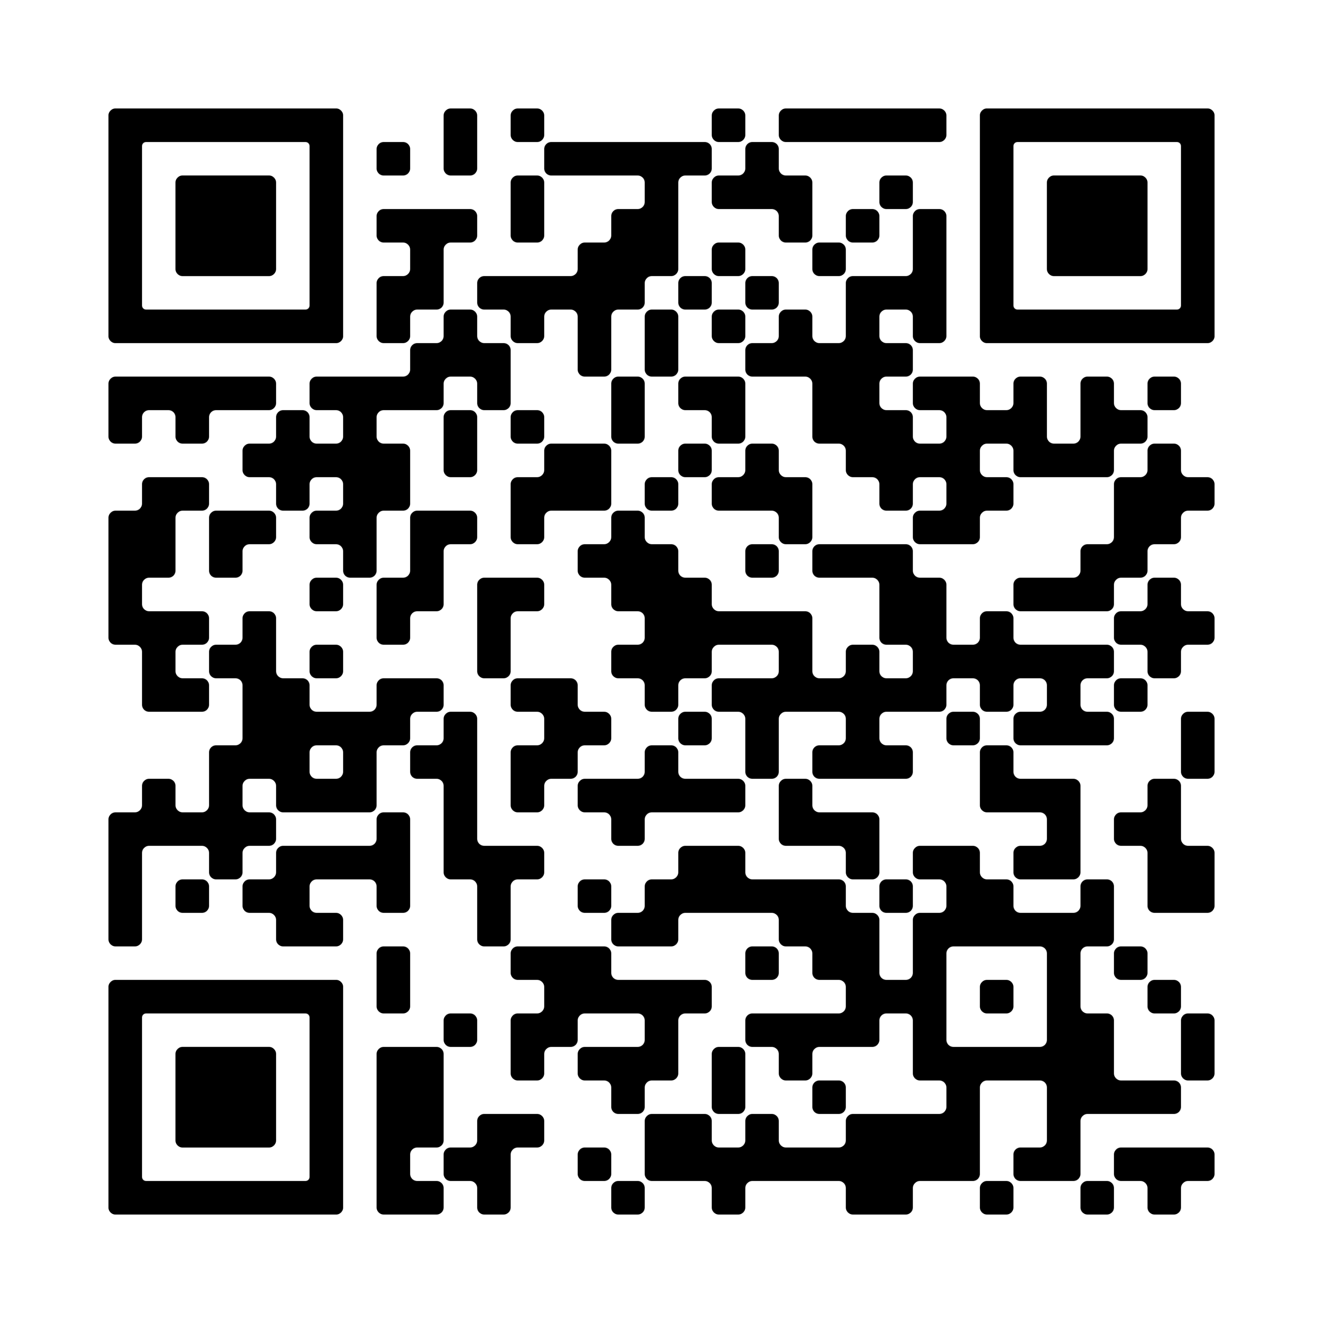
Children’s Physiotherapy Team - Connect NHS
They can:
- look at strength and co-ordination, motor development, posture and balance
- give quality of movement advice to parents, carers and other relevant professionals
- refer onto other services
- provide physical management programmes for home nursery and schools
- undertake assessment for specialist equipment
- assessment for Orthotic needs
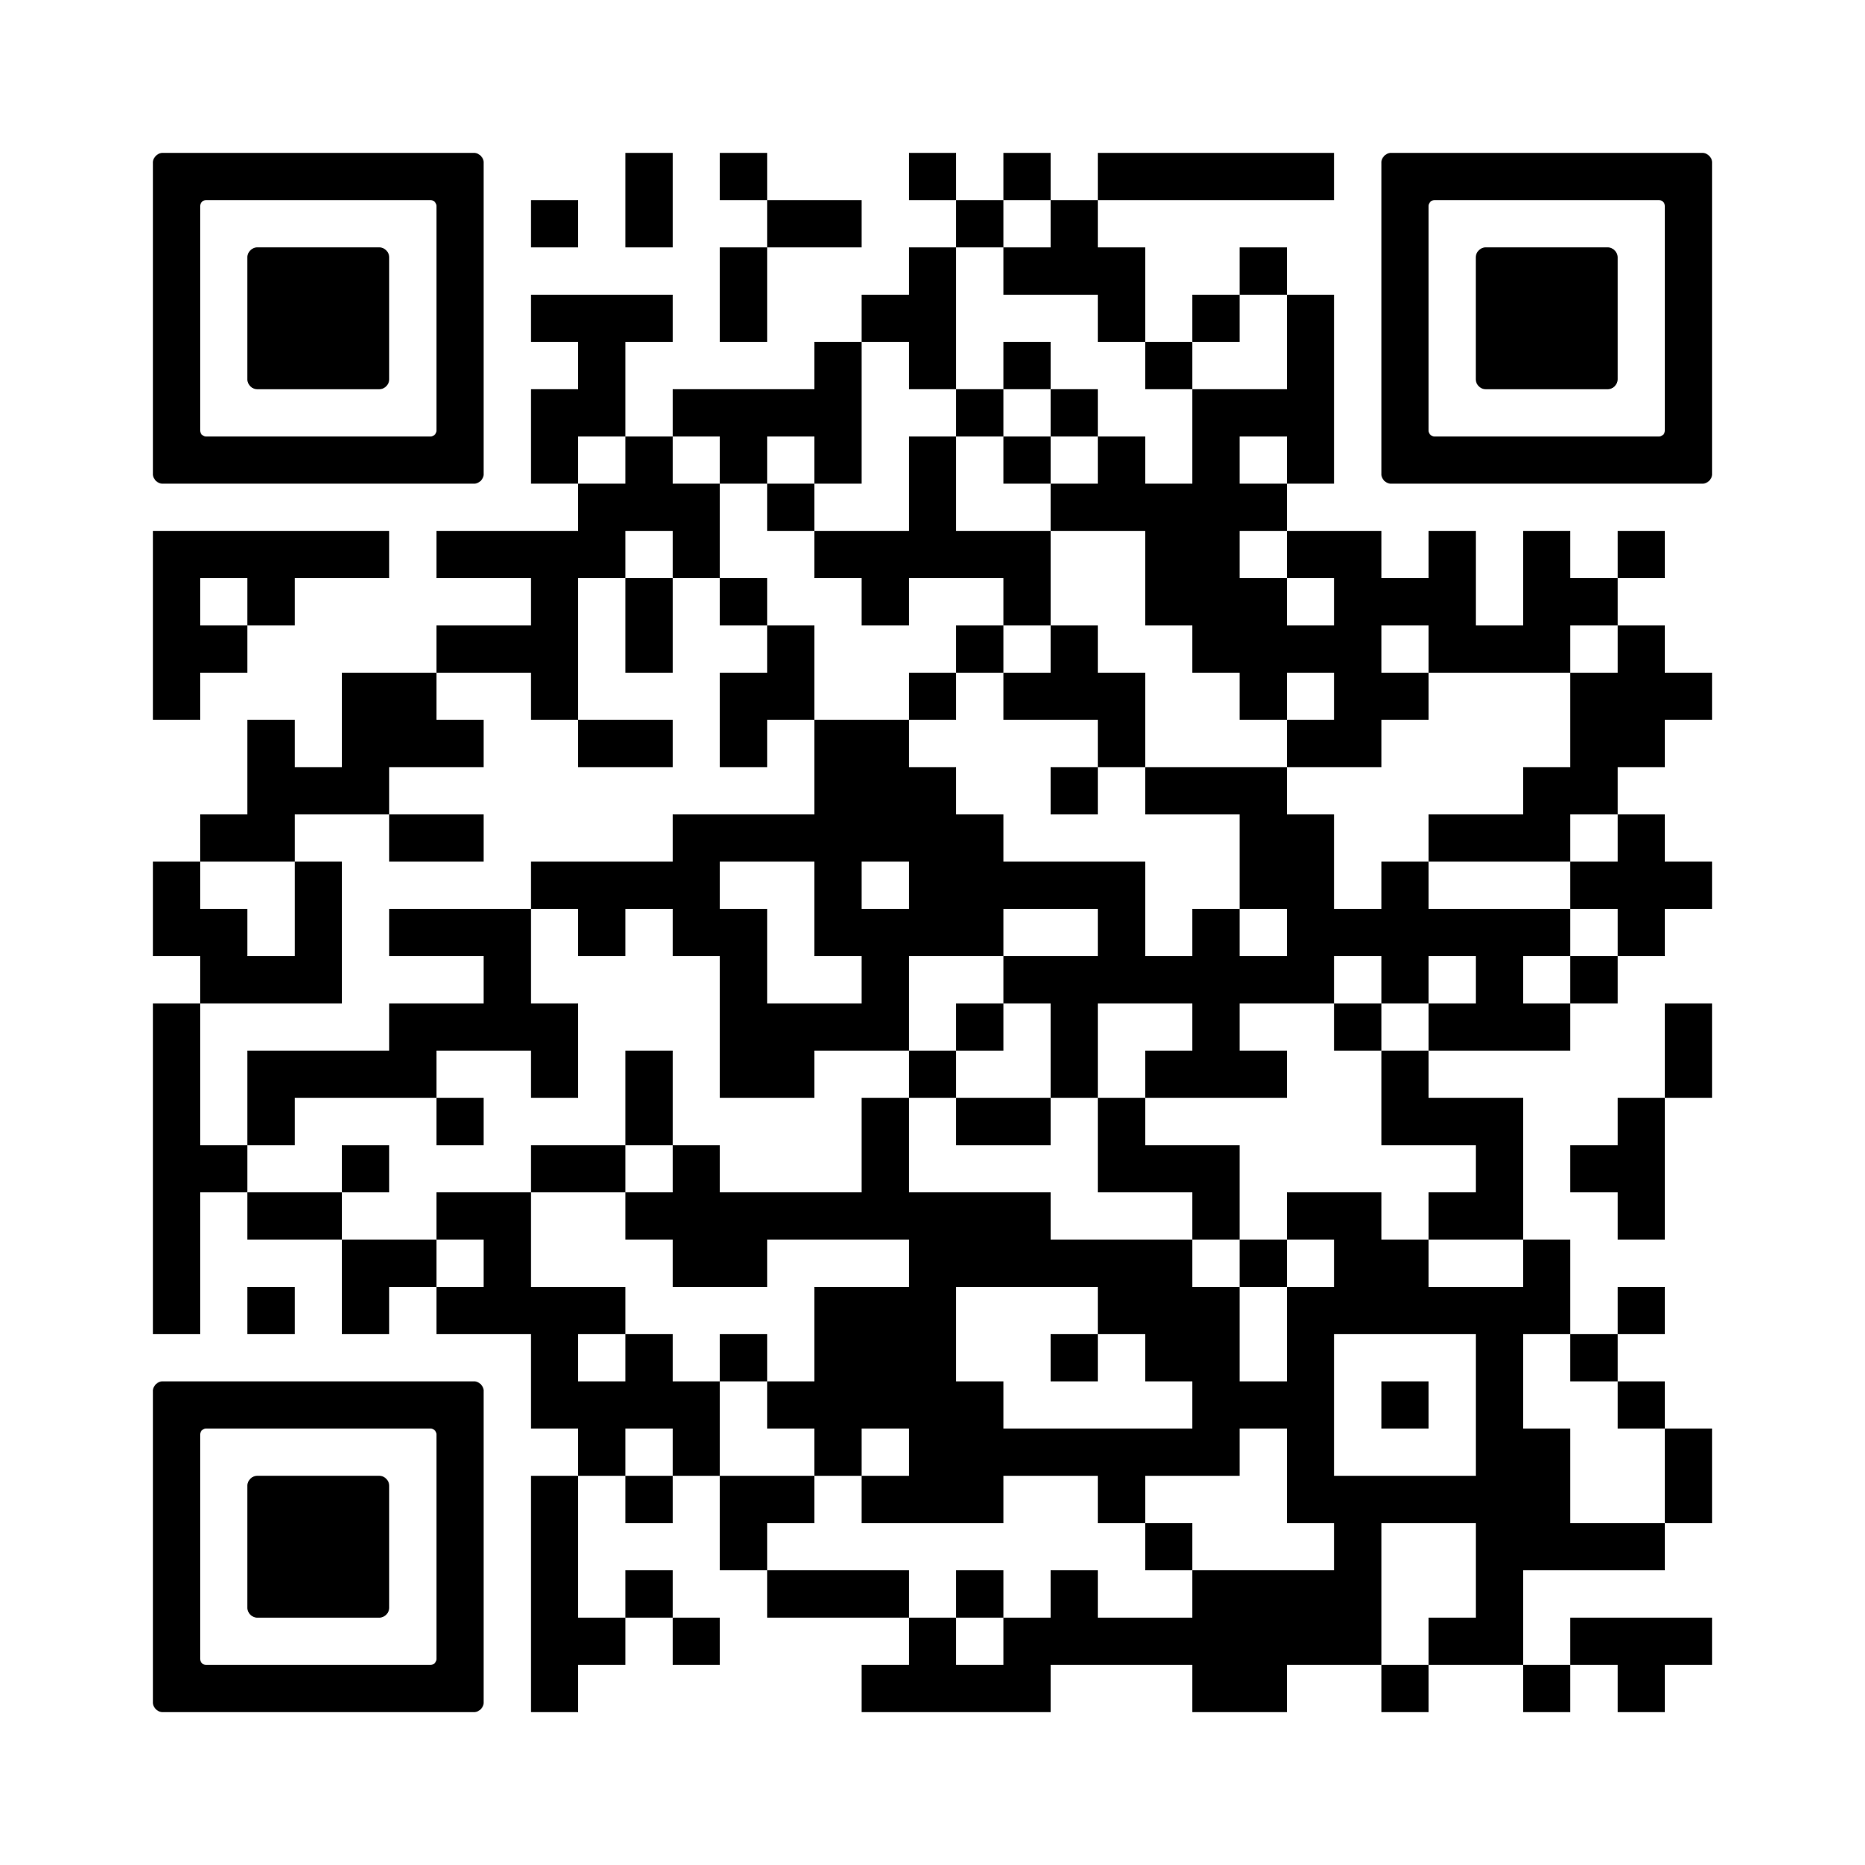
Children's Occupational Therapy - Connect NHS

Movement issues - Occupational therapy
Everyone has an occupation. A child’s occupation is to grow, learn and play.
Working as part of a team, occupational therapists can help children and young people to learn different ways to carry out everyday activities that they may find difficult because of their illness, injury or disability. Occupational therapists enable these children to be as independent as possible in their home, educational and other community settings.

Medication
Altered muscle tone such as spasticity can affect a child’s control of movements, contribute to the development of muscle contractures, and can also cause pain. Some oral medications can also help muscle tone. Some medications are taken orally (e.g. baclofen) and others are injected or delivered through surgically implanted pumps (e.g. Baclofen). Many children with cerebral palsy benefit from Botulinum toxin type A injections into muscles affected by spasticity. This intervention is used from about two years of age and is most effective when used in conjunction with therapy. Your medical team will discuss options with you.

Surgical procedures
Selective Dorsal Rhizotomy (SDR) is a neurosurgical procedure that is used in a small percentage of children with cerebral palsy to permanently reduce spasticity in their legs. Your team will discuss thresholds for referral to the specialist service at Leeds General Infirmary.

Muscle, bone and joint issues
Bone health is another reason why individuals with cerebral palsy should consider a daily program of physical activity. Ideally this would include short bursts of activity throughout the day, and targeted exercise programs for musculoskeletal and cardiovascular health. All physical exercise programs should be safe, and for individuals with cerebral palsy that includes joint protection and dynamic stretching to prevent injury, and a postural management plan will be developed with the therapy teams. Your child will have structured review within the CPIP pathway. CPIPUK is a follow-up programme for children with cerebral palsy or suspected cerebral palsy, allowing early detection of changes in muscles and joints with the option of earlier treatment for your child
It can also be helpful to have adequate levels of Vitamin D and calcium in diet and use supplements as advised by the medical team
Surgical procedures: Orthopaedic surgeons correct joint deformities and lengthen muscles. Surgery usually takes place in a child’s late primary years or early adolescence to improve walking quality and reduce pain. Your child will be seen in an MDT clinic to support the management of some of the conditions associated with cerebral palsy, such as spasticity, musculoskeletal issues and growth. See Appendix 1.

Communication issues
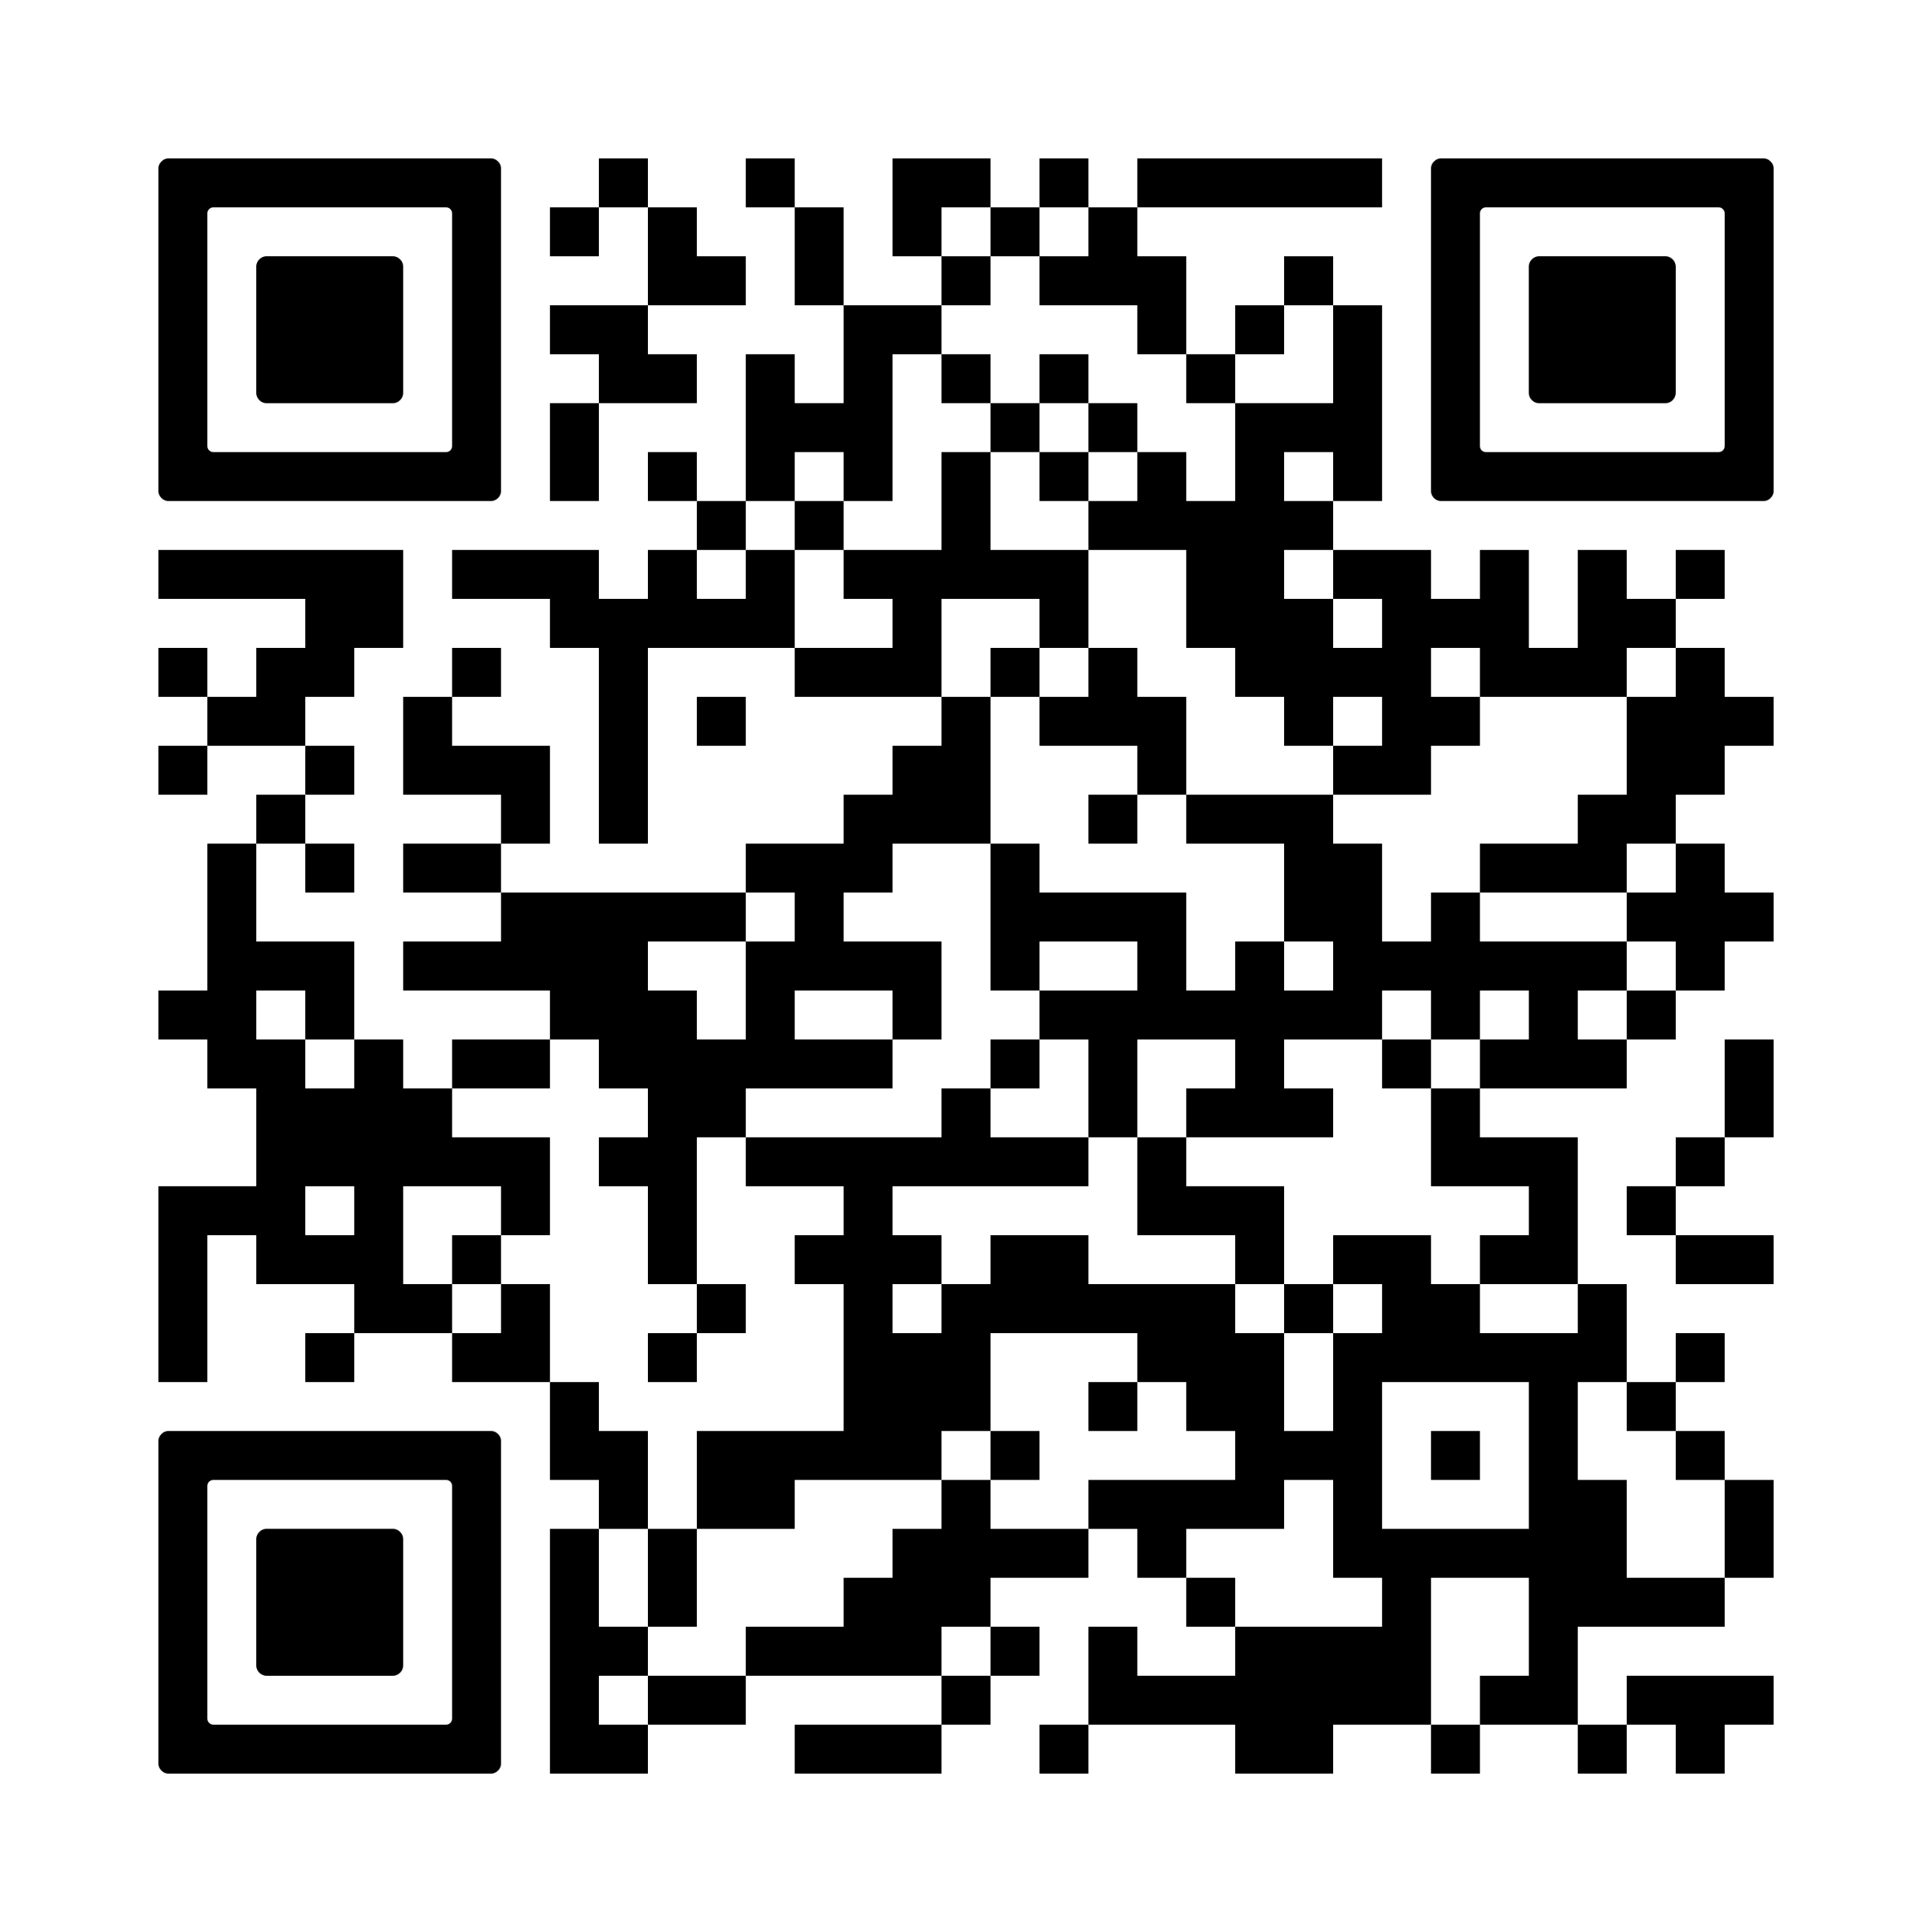
Children’s Speech and Language Therapy
- Connect NHS
Communication is complex and two ways. Children can have a range of skills in expressing themselves, to understand others, and be understood. Some of these skills may be affected by cerebral palsy more than others.
Speech and language therapists provide treatment, support and care for children who have difficulties with communication, or with eating, drinking and swallowing. This includes understanding what is being said and learning to use words and sentences. Treatment (intervention) for communication often involves the use of augmentative or alternative communication systems, such as signing, communication boards and speech generating devices.

Pain management
Assessing pain in cerebral palsy (CP) can be challenging due to communication difficulties, cognitive impairments, and varying sensory processing abilities. The team will rely on observation, parent and carer reports and feedback from therapy teams to assess for pain symptoms. Management will be individualised and may include:
- Targeted postural management programme with support from physiotherapy and occupational therapy teams
- Medication: Pain may be treated through medication and by addressing the underlying cause of the pain, e.g. by treating muscle contractures.
- Cognitive-behavioural therapy: Psychologists may offer cognitive-behavioural therapy for chronic pain. This process works to help a person change the way they think about pain and, in turn, how they feel and behave about pain.
- Massage therapy and hydrotherapy: Temporary relief of pain may be assisted through massage or hydrotherapy.

Epilepsy
If there are concerns about seizures, please obtain videos of episodes and inform your clinical team. We will link with the epilepsy team for an urgent review.
If Epilepsy is confirmed, we will advise on safety measures and may prescribe anti-epileptic medication to minimise the number of seizures. The epilepsy team will also guide families on the management of seizures if they do occur.

Respiratory support
Need more information?
Child Flu Vaccine
- NHS UK
Your child’s respiratory health will be reviewed as part of the clinic assessment.
Early identification and treatment of respiratory problems can significantly improve outcomes.
If your child is in the high-risk category, we will offer targeted respiratory therapy that can help improve lung function, breathing techniques, and secretion management.
Medications may be used to treat infections, manage infections, or help with breathing.
Every winter in the UK, thousands of children, even those without underlying health conditions, need hospital care because of flu. The best way to help protect your child is to get them vaccinated against flu. The flu vaccine is safe, effective, and offered free by the NHS.

Sleep issues
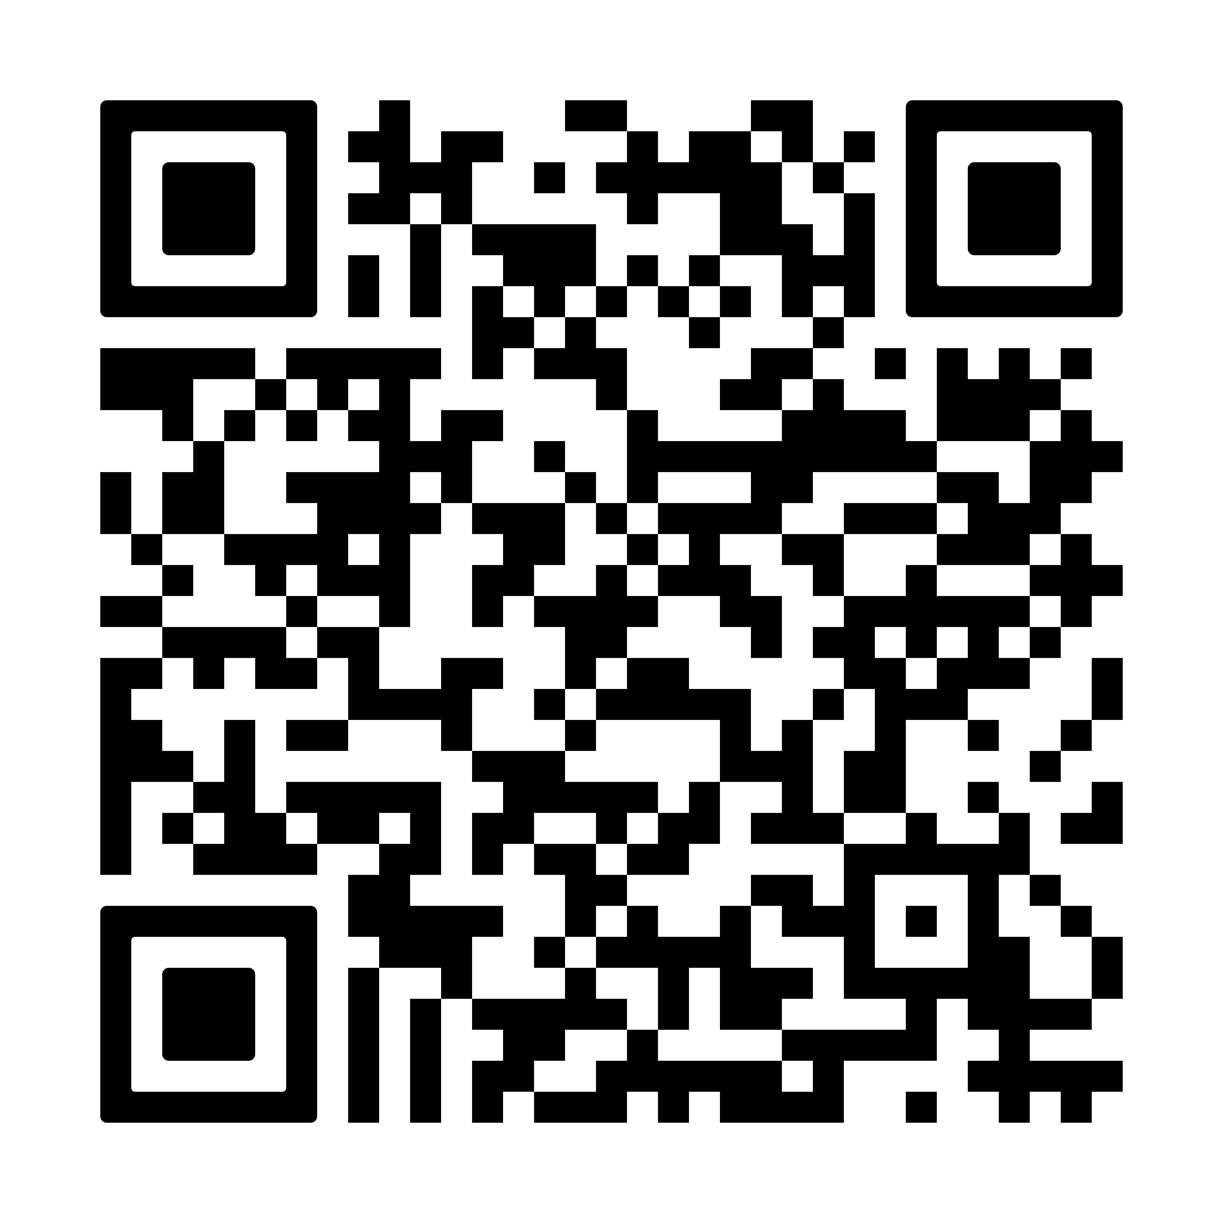
Generic sleep advice
Sleep and young children
- NHS UK
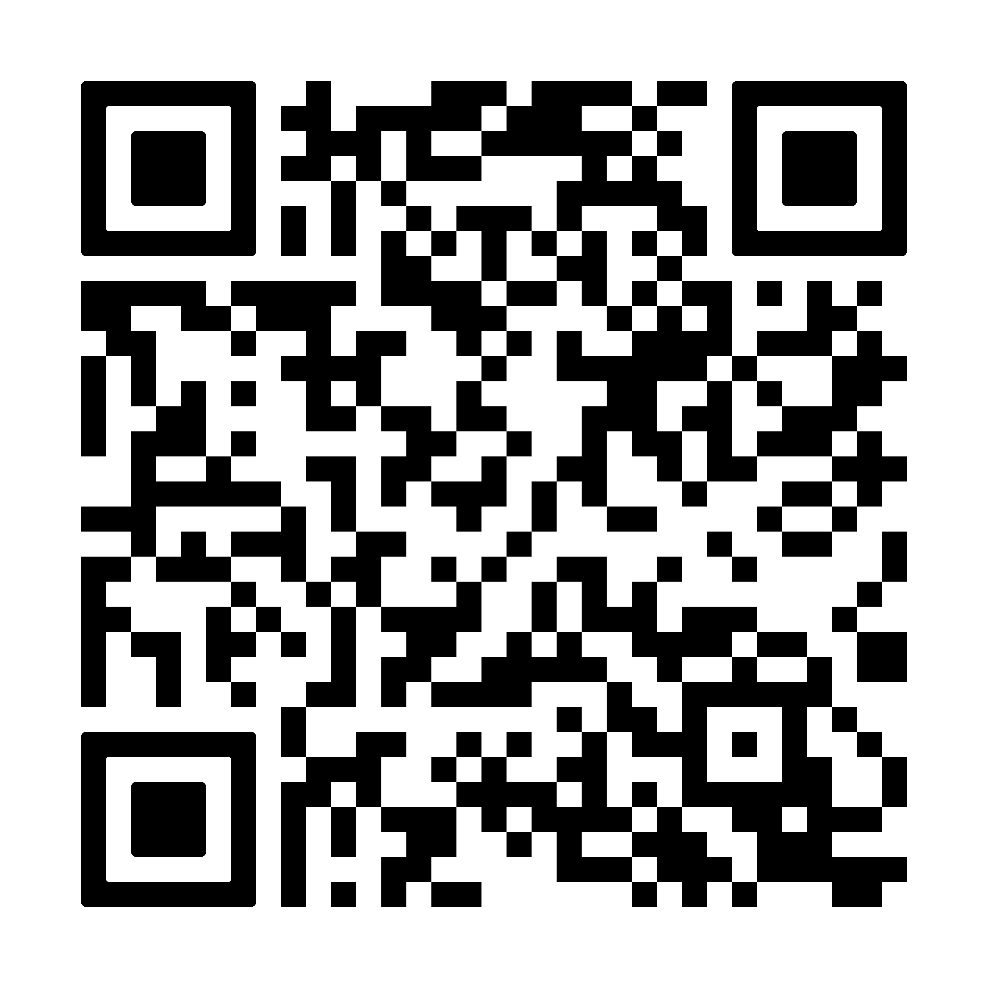
Additional targeted information about sleep problems etc.
The Sleep Charity
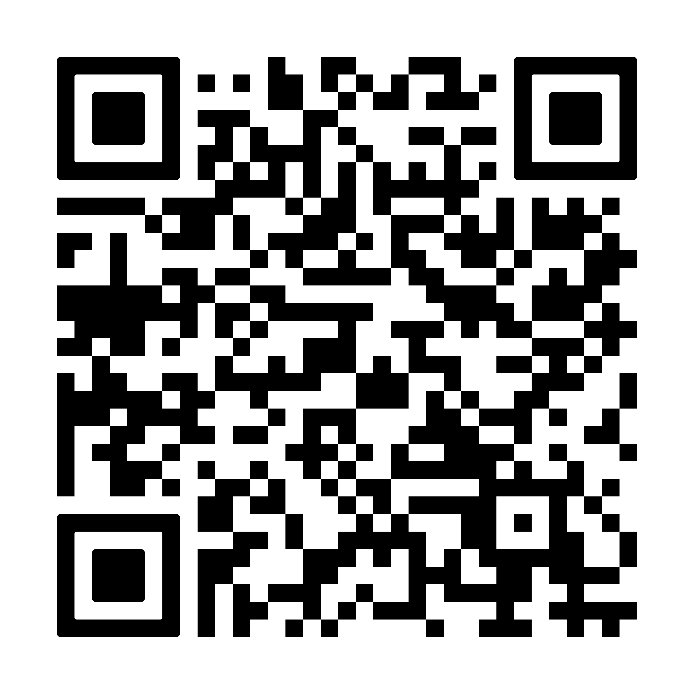
SEND sleep service (Hull) - kids.org.uk
If the family wish, they can also contact their health visitor or the early help worker.
Sleep services provide trained sleep practitioners who can support and advise families on their children’s sleep problems and support them to put effective strategies in place. The practitioners also give parents coping mechanisms to help with their own sleep deprivation. Help is provided through the delivery of sleep workshops and individualised support.
Once behavioural strategies have been trialled, we may prescribe medication or treat the associated issues that affect sleep.
Sleep systems: For children with postural issues that make sleep difficult, occupational therapists and physiotherapists may prescribe special sleep systems to help children feel more comfortable in bed.

Interventions for issues with eating, digestion and nutrition
Swallowing problems are common and often not recognised.
As part of the medical review your child will have regular check-ups for swallowing problems and other members of the clinical team will be involved in offering support based on individual clinical needs
- Medication and surgery:
Treatment (intervention) for severe difficulties with digestion, such as gastro-oesophageal reflux (GOR), constipation includes medications or sometimes surgery. If your child has severely limited eating skills or experiences an unsafe swallow, non-oral feeding may be recommended. This involves a surgically inserted feeding tube to the stomach or the small intestine. You child will be referred to specialist in Gastroenterology and paediatric surgery to facilitate discussions.
- Speech and Language Therapy (SALT):
SALT provide assessment and treatment for eating, drinking and swallowing difficulties. Examples of these are learning to use the muscles of the mouth better, using specially designed utensils and sitting in an optimal position.
- Dietician:
The Paediatric Dietician will work with young people and their parent or carer to achieve optimal nutrition.
They support children and their families where nutrition and special diets can be part of their treatment. If a child isn’t growing well, has difficulty feeding, or has special diet needs, a paediatric dietician may be able to help.
- Oral and dental health:
Patients with cerebral palsy are at a greater risk for dental issues and poor oral health related to reflux, drooling, medications with sugar, difficulties with chewing and swallowing, lack of control when using a toothbrush. Attend your dentist at least once every 1-2 years – your dentist will tell you how often you should come back. Brush your teeth with fluoride toothpaste daily – spit the toothpaste out but do not rinse with mouthwash or water. Try to reduce the sugar in your diet, snacking on tooth-friendly food like fruit and vegetables. Most children will be supported by their regular dentist however some children will be referred to a special needs dentist for additional support.
Children’s teeth
- NHS UK

Brush My Teeth

Autism Toothcare

Interventions for intellectual disability and learning difficulties
A cerebral palsy diagnosis does not mean that a child will have cognitive issues, although cerebral palsy can be associated with learning difficulties or learning disability. Some children with cerebral palsy might also have other conditions such as epilepsy, which can also affect a child’s cognitive ability. Differences in ability can be due to difficulties in cognition or due to the other challenges associated with cerebral palsy such as communication, sensory issues, movement (writing, taking part) and fatigue for example.
Here is some information on how cerebral palsy can affect school and learning:

Council for disabled children
- early support cerebral palsy

Taking the leap
- CanChild

Local Support

Accessing support for learning and school

The Hull SEND Local Offer - SENDIASS
If you feel your child is struggling with their learning and may need additional support at school, speaking to the school’s SENCO is a good place to start. They are a Special Educational Needs Coordinator and will be able to offer you support.
You can also speak to SENDIASS, a Special Educational Needs and Disabilities Information, Advice & Support Service who offer free advice around how to access support for your child and their learning needs. They can advise on processes such as getting an educational health care plan (EHCP) to have more individualised support.
- Hull SENDIASS helpline: 01482 467540
- East Riding SENDIASS helpline: 01482 396469
Your Health visitor can also help you in initiating referral for Early support and Portage.
- Hull IPHNs Email:
hull.cypcommunityservices@nhs.net
01482 259600
- East Riding ISPHN Email:
hnf-tr.isphnspoc@nhs.net
01482 689689

Portage
portage.org.uk
Portage is a home-visiting educational service for pre-school children and their families.
Portage aims to work with families to help them develop a quality of life and experience, for themselves and their young children, in which they can learn together and play together.

Interventions for behaviour and emotional issues
It is not easy to receive any medical diagnosis for your child, and this can bring about new emotions and challenges. The Mencap and Scope website has some useful pages on dealing with a disability diagnosis and thinking about the future:

Diagnosis
- Mencap
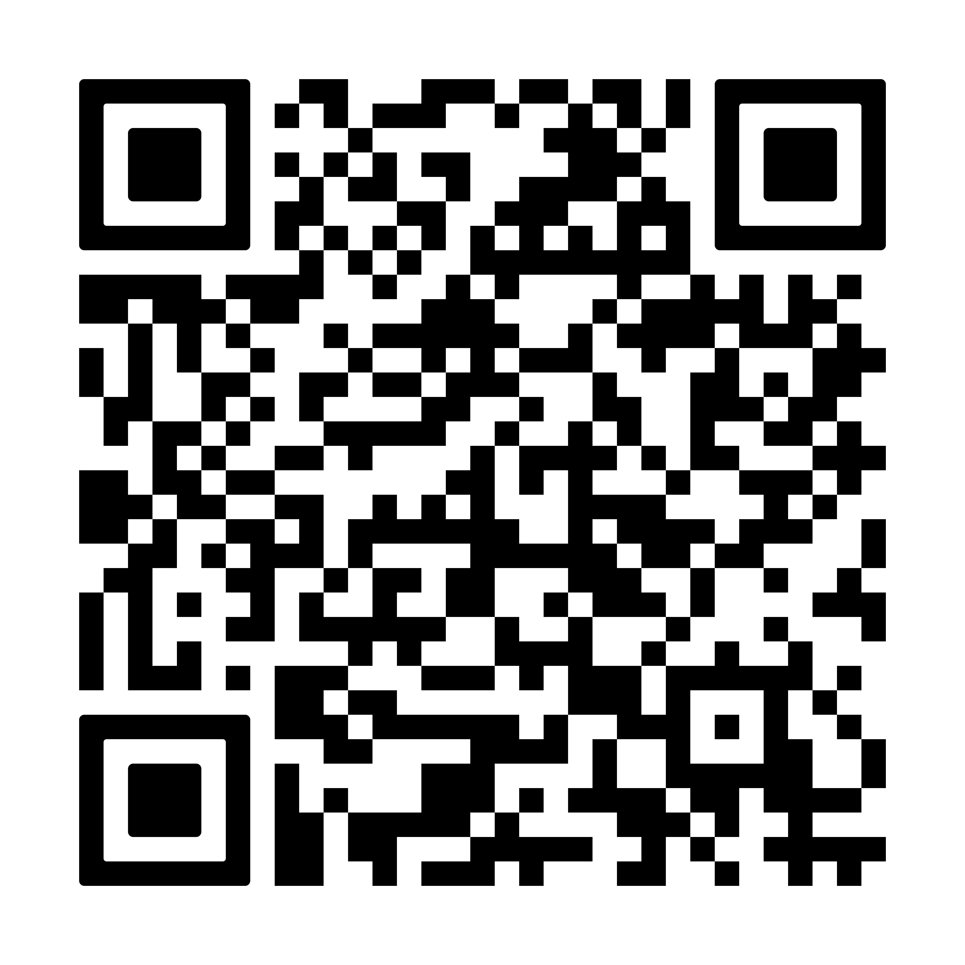
Families with disabled children - Scope

Mental and Emotional Wellbeing
MIND-Ed and Youngminds also has free modules to access for parents on a wide range of supportive topics:
MindED

Youngminds
Parents/ adults can seek support via their GP if there are specific areas they need support with individually.

Behavioural difficulties and Neurodiversity assessments

The Challenging Behaviour Foundation
The challenges a young person with CP experiences can make behaviours that are challenging to others more likely at times or in some situations. Understanding the purpose of these behaviours will help support the young person, as behaviour is often a way of communicating a need.
The challenging behaviour website contains useful information, resources and support.
Children and Young People may sometimes show a range of needs and emotions through their actions and behaviour. Consider factors such as pain, discomfort, frustration, communication difficulties, sources and experiences of sadness and anxiety and difficulties in school.

Emotional and mental health support - The East Riding Safeguarding Children Partnership (ERSCP)

If support is needed around behavioural difficulties for someone with cerebral palsy you can seek targeted support from specialist nurses. You could also talk to your child’s school. Sometimes it helps to work out how to support a child to know whether any difficulties are seen at home, school, other places or everywhere. Consider referral to:
- Children’s Wellbeing Practitioner / Education Mental Health Practitioner (MHST)
Telephone: 01482 303688

Children's Neurodiversity Front Door Team
- Connect NHS
- Mind Counselling
Telephone: 01482 240200
- East Riding Children’s Wellbeing Practitioners (ERYC)
Telephone: 01482 391700
For concerns about Autism / ADHD the referral pathway is through the Neurodiversity service, please discuss with SENCO at school.

Social Care
Children's Social Care Team is a specialist service with a remit to work with children and young people with a severe disability and complex needs and their families. Children often require an integrated approach across Health, Education and Social Care and may require long term support from the specialist Social Work Team throughout their childhood and into adulthood.
They can help provide you with information, support and advice. They can:
- advise you about aids, equipment and adaptations to the home
- provide information and advice about financial help available to you and child with a disability or additional needs, such as direct payments
- help you find activities for your child throughout the year
- provide information about support groups for you and your child
- provide you with information about short breaks and holiday activities for you and your child
- provide information about help with parking using the blue badge scheme, and how to apply
- provide advice and support in moving on to adult services

The Local Offer website– Hull and East Riding of Yorkshire
This is where you can find a range of services available in the area to support parents, children and young people aged 0–25 years with Special Educational Needs and Disability (SEND). The Local Offer aims to make it as easy as possible for children, young people and their families to access services and achieve their goals.

Hull SEND Local Offer
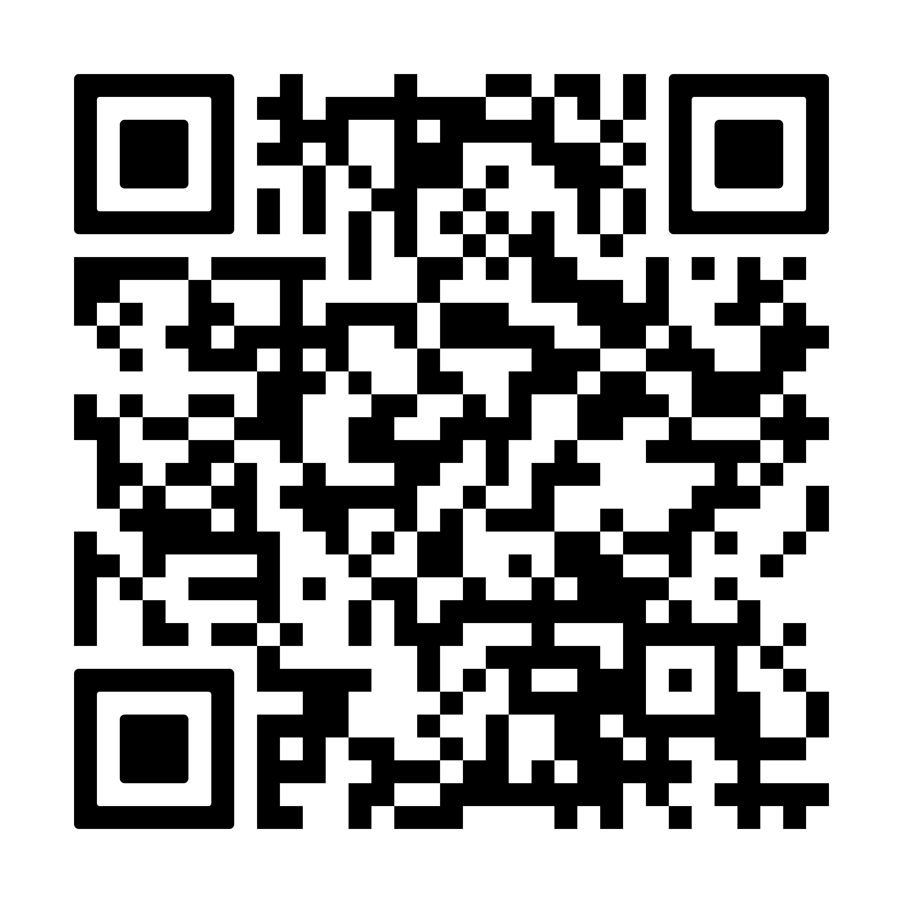
Early help family support - hull.gov.uk
If you are unable to complete the online form you can contact an Early Help Locality Hub on one of the numbers below:
- North Locality Hub – 01482 828 901
- East Locality Hub – 01482 708 953
- West Locality Hub – 01482 305 770

East Riding local offer

East Riding
- Early years SEN help

East Riding - Family help
Phone 01482 391700 for a consultation with one of the early help practitioners. Early help practitioners are available Monday to Friday 9am - 4pm.

Section 4 - Helpful Information
Community Children’s Physiotherapy Service
Entrance B
Townend Court
Cottingham Road
Hull
HU6 8QR
Tel: 01482 336774

CPIPUK
Cerebral Palsy Integrated Pathway United Kingdom
Information for parents

What is ‘CPIPUK’?
CPIPUK is a follow-up programme for children with cerebral palsy or suspected cerebral palsy, allowing early detection of changes in muscles and joints with the option of earlier treatment for your child. This may prevent problems developing in the future.

What is Cerebral Palsy?
Cerebral Palsy (CP) is the term used for the physical disorder caused by brain injury or dysfunction occurring before the age of two. There are many different causes of cerebral palsy and the degree of functional impairment varies in each child from nearly normal function, to pronounced functional impairment.
Children with cerebral palsy often have increased tone (spasticity) in certain muscles while other muscles may be weakened. This can interfere with children’s ability to move and to learn to walk. Spasticity can also cause pain, and over time, shortening of muscles and tendons. When joints do not move normally they become permanently stiff because the soft tissues tighten around them (known as a contracture).
In some children, the imbalance in the hip joint can lead to pulling of the head of the thigh bone out of its position in the hip joint leading to hip dislocation. Imbalance in the back, can lead to a curved spine or scoliosis. There are many different treatment methods to decrease spasticity and to prevent contractures and hip dislocation. These may include exercise or stretching and positioning programmes from your physiotherapist, the use of splints during the day or at night or drug treatments to reduce the tightness in muscles. This does not describe all the treatments available. It is very important that the right treatments are available at an early stage to help prevent problems developing in order to achieve the best possible outcome.

What is the purpose of CPIPUK?
The purpose of CPIPUK is to ensure that children with risk of developing contractures or hip dislocation are detected early enabling timely intervention. The goal is that no child should be affected by severe contractures or hip dislocation and that every child should receive the best possible function possible. Research has shown that x-rays of the hip taken at the right time can help us spot this problem earlier – and take steps to reduce the chance of it getting worse.
The follow-up within CPIPUK involves the child’s physiotherapist who will make an assessment of the child’s muscle tone, joint motion, ability and function twice a year until the child is aged six. After that, annual assessment is made until the child reaches adulthood. These assessments help the physiotherapist decide how often your child needs to be seen for treatment and what treatment options are best for your child. Regular assessment and early treatment combine to improve outcomes.

X-Rays
Children with CP should have an x-ray at 2 years of age. If your child is mildly affected you can expect one further x-ray aged 6 years. For those more severely affected there will be annual x-rays until age 8 years and then every other year. This is because there is a greater risk of hip dislocation in more severe cases.
All children will be invited for a final x-ray at age 16.

How successful is CPIPUK?
Children treated under a similar programme in Sweden experienced significantly fewer hip dislocations, significantly fewer children from this group developed major contractures and scoliosis through participation in the programme. There was also a decrease in the number of major orthopaedic operations performed for hip dislocation and the co-operation between different specialists involved in the care of children with cerebral palsy improved. Scotland has this programme in place and it is now being introduced across England.

CPIPUK in Hull/East Yorkshire
CPIPUK is being introduced in your area and this is why you are receiving this information. We will be inviting your child for an assessment and subsequent follow up assessments. The information from these assessments will be shared with parents, Paediatricians and Orthopaedic Doctors to help plan your child’s treatment and monitor them as they grow and develop.
The assessment works on a traffic light system – indicating areas that require monitoring, immediate action or no concern.
(Reference: The above information has been taken from CPIPS – Cerebral palsy Integrated Pathway Scotland, Information for Parents Leaflet)

